|  |  |  |
| --- | --- | --- |
| **LAB 321Assignment** | **Type:** | **LongAssignment** |
| **Code:** | **J3.L.P0024** |
| **LOC:** | **700** |
| **Slot(s):** | **15** |

**Title:** Melville Family Farm Store

**Background**

### You want to startup with Family Farm Store

Complete this assignment to make your farm store online now☺

Reference site:<http://www.simplesite.com/us-123farm-store>

**Program Specifications**

Program a web site tointroduce your Family Farm Storeservices, detail functions of this website is described below

**Features:**

This website contains 3 main functions

* Function 1 : Online Store page : ( see PIC 01)
  + Displayall item including
    - Item name
    - Description picture
    - Price
  + When user click to “Add to basket” button ,”Your basket” will crease by 1
  + When user click to ‘Checkout” button , show “Checkout” form ( PIC 02)
* Function 2 : Blog( PIC 03)
  + Display top 3 item ( different type ) sort by published date
  + When user click to “Overview” link , system display all items with short description
* Function 3 : Come and visit us ( PIC 04)
  + Display contact and address information

You do not need to write interface for admin control panel, you can add data manually (use SQL SERVER Management studio).

Note: All data must be load from database, not hard code in page.

***Expectation of User interface:***

Pic 01 : Online Store

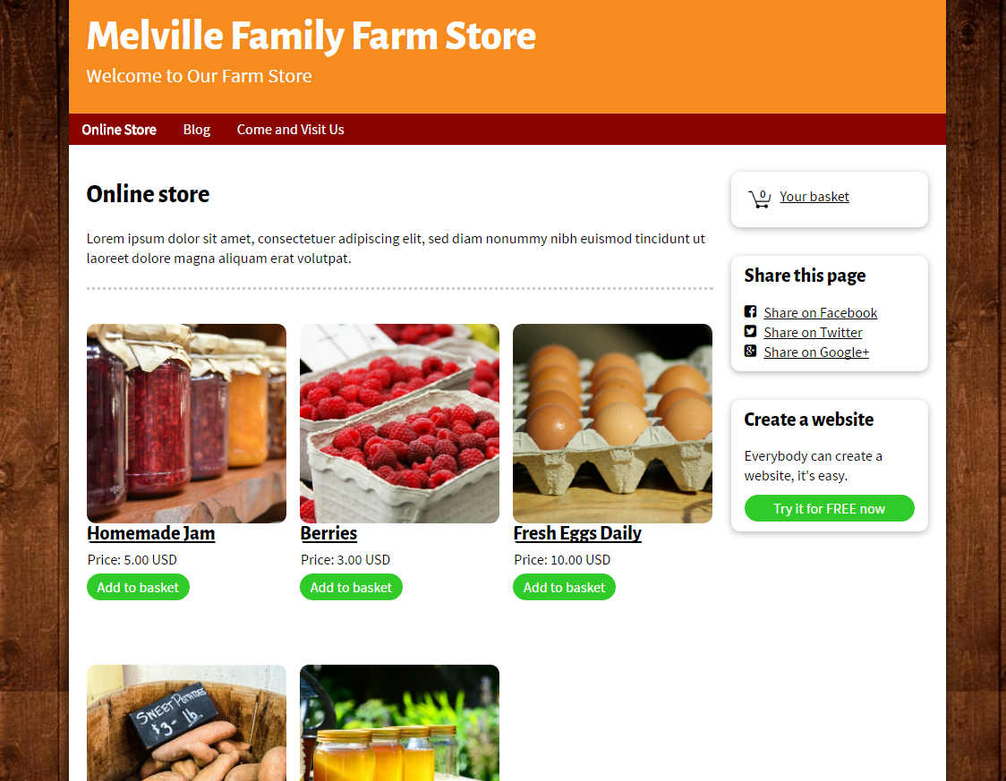

PIC 02 : When click to “basket”, show “Checkout form”

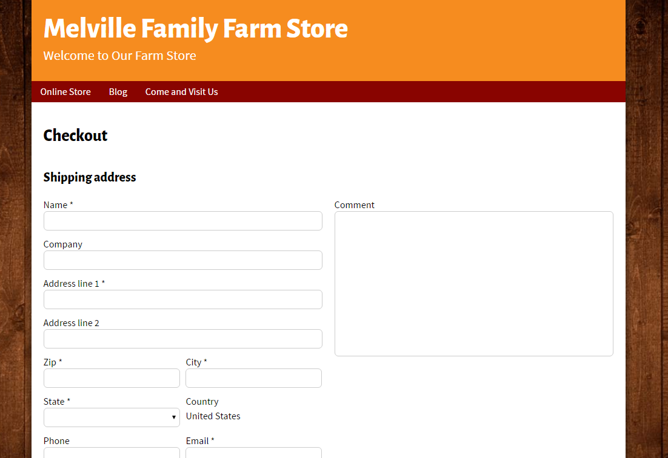

PIC 03 : BLOG

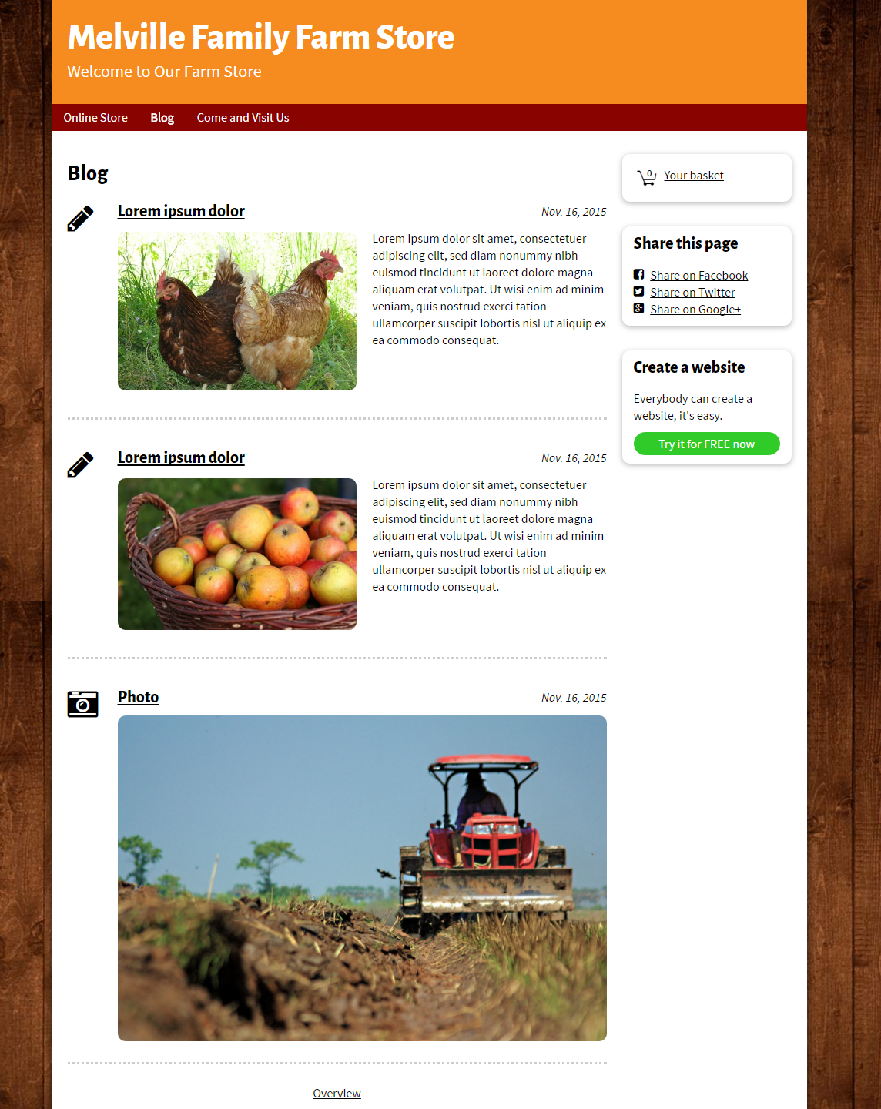

PIC 04 : Come and visit us

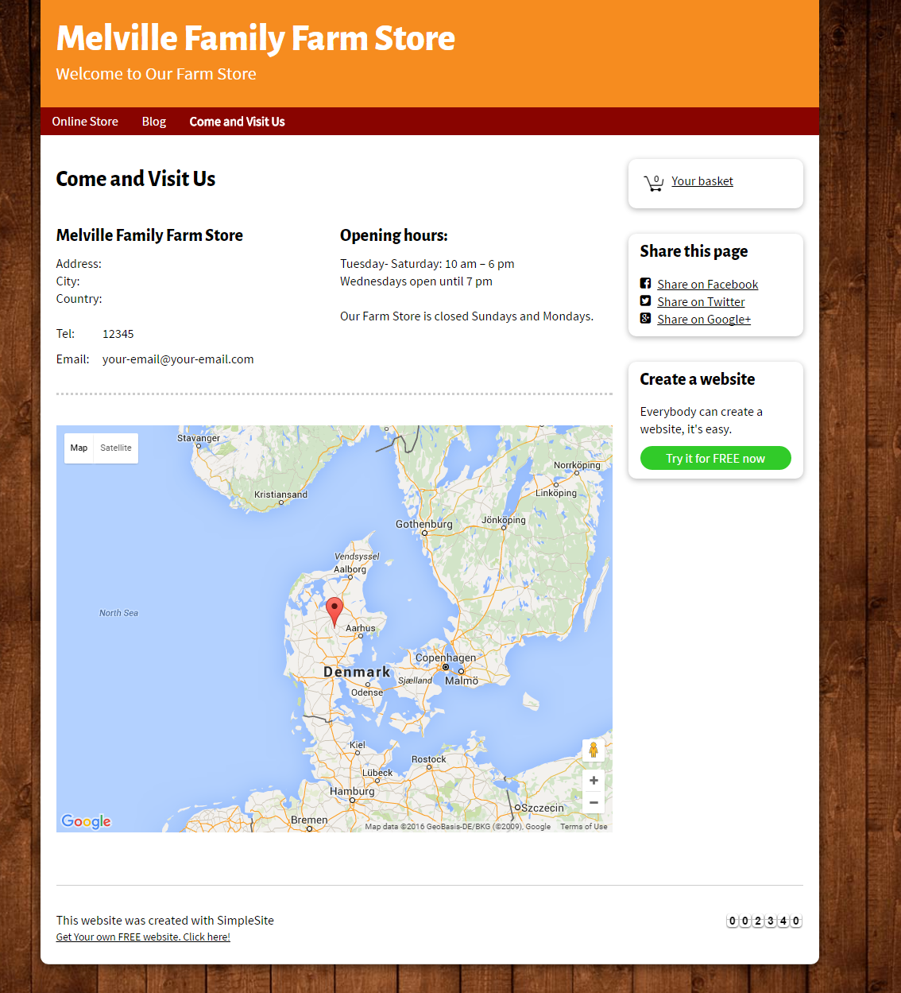

**Guidelines**

* Step 1 : Clarify requirement & scope with mentor
* Step 2 : Create prototype
* Step 3 : Design database base on created prototype
* Step 4 : Code & Test